CSA 1514-CLOUD COMPUTING

QUESTION 1
Create a simple cloud software application for Flight Reservation System using any Cloud Service Provider to demonstrate SaaS include the necessary fields such as one way, round trip, From, to, Departure, Departure, Travelers & Class, Fare Type, International and Domestic Flights etc.
Aim: To develop a simple cloud-based flight reservation application demonstrating SaaS with domestic/international flight and booking options.
Output
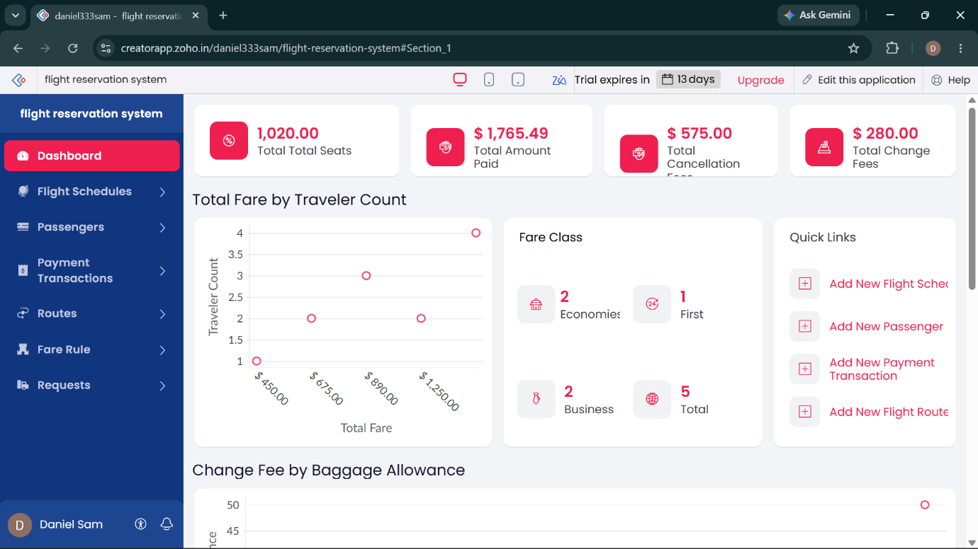

QUESTION 2
Create a simple cloud software application for Property Buying & Rental process (In Chennai city) using any Cloud Service Provider to demonstrate SaaS include the necessary fields such as Buy, Rent, commercial, Rental Agreement, Rental Agreement, Area, place, Range, property value etc.
Aim: To develop a simple cloud-based property buying and rental application for Chennai demonstrating SaaS with property search and agreement details.
Output
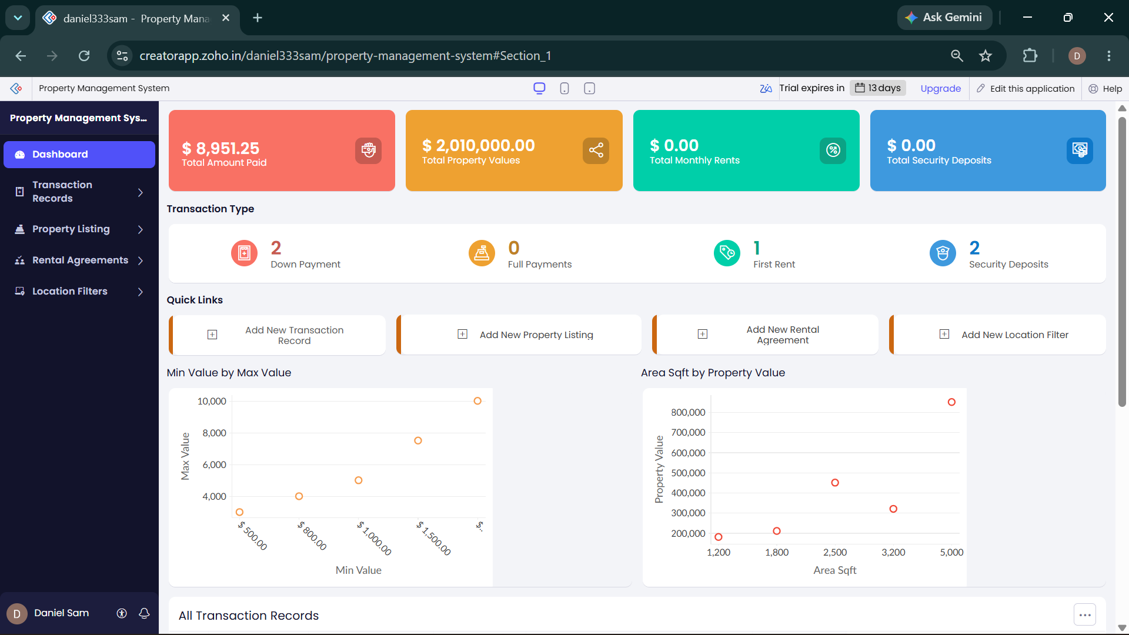

QUESTION 3
Create a simple cloud software application for Car Booking Reservation System using any Cloud Service Provider to demonstrate SaaS include the necessary fields such as search for cabs, from, to, rental, out station, Package type, hours/Days etc.
Aim: To develop a simple cloud-based car booking reservation application demonstrating SaaS with cab, rental, out-station and package options.
Output
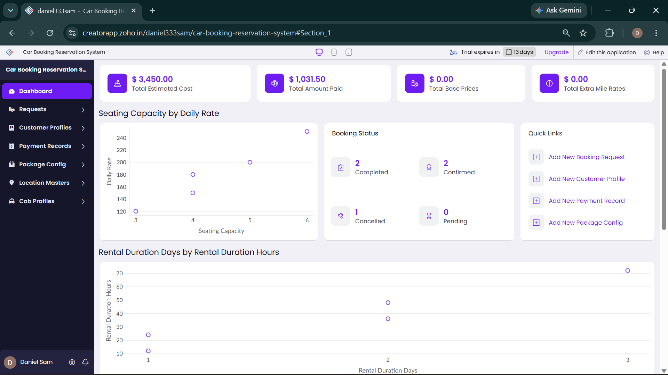

QUESTION 4
Create a simple cloud software application for Library book reservation system for SIMATS library using any Cloud Service Provider to demonstrate SaaS include the necessary fields such as Title of the book, author, publications, Year, edition, no of copies, Rack no, status (taken/returned) etc.
Aim: To develop a simple cloud-based SIMATS library reservation application demonstrating SaaS for managing book details and availability status.
Output
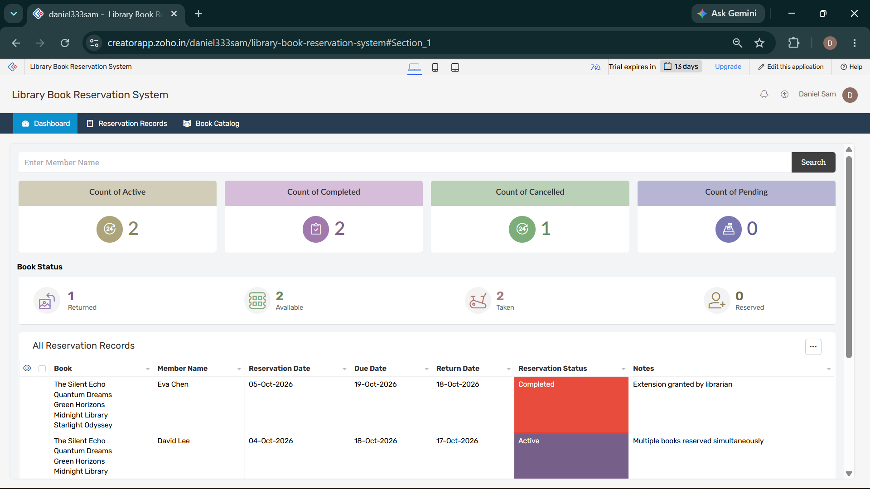

QUESTION 5
Create a simple cloud software application for Mark Sheet Processing System using any Cloud Service Provider to demonstrate SaaS include the necessary fields such as name of the student, Reg no of the student, Subjects, Marks, Average, percentage, rank, overall performance etc.
Aim: To develop a simple cloud-based mark sheet processing application demonstrating SaaS for storing marks and calculating academic performance.
Output
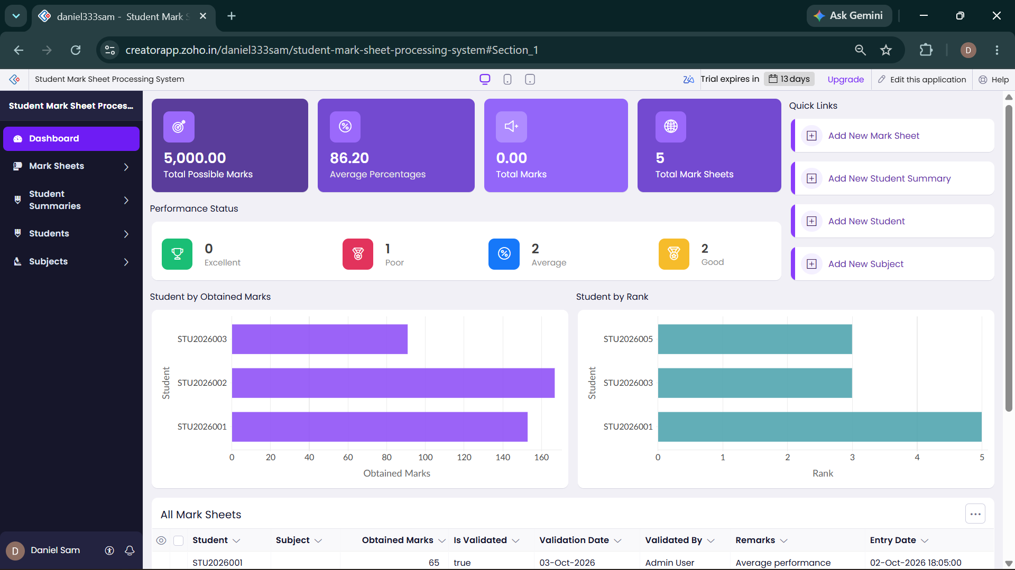

QUESTION 6
Create a simple cloud software application for Payroll Processing System using any Cloud Service Provider to demonstrate SaaS include the necessary fields such as Name of the employee, experience in present org, over all experience, basic pay, HRA, DA, TA, net pay, gross pay etc.
Aim: To develop a simple cloud-based payroll processing application demonstrating SaaS for managing employee salary and payroll details.
Output
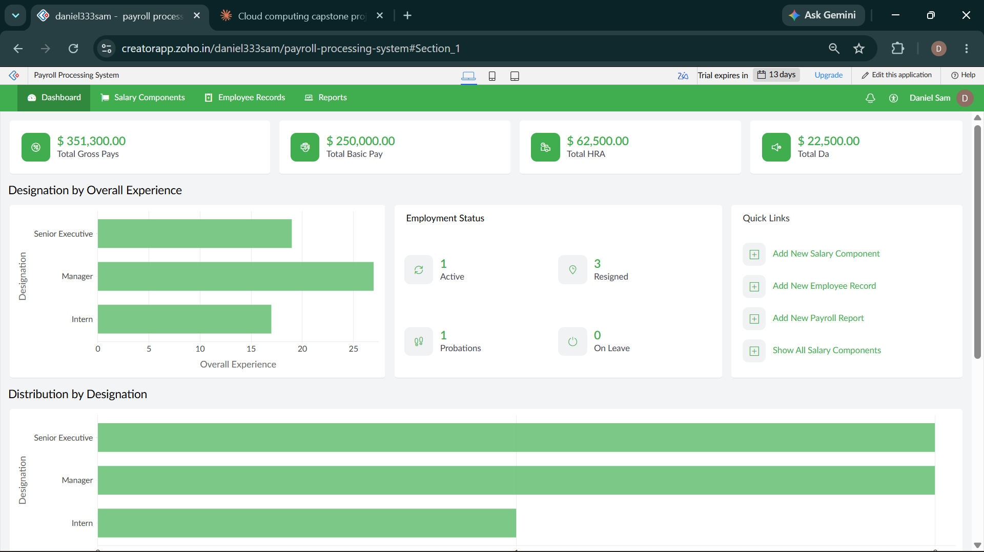

QUESTION 7
Create a simple cloud software application for Students Attendance System using any Cloud Service Provider to demonstrate SaaS include the necessary fields such as name of the students, course, present, Absent, course attendance, OD request, grade, attendance percentage, etc.
Aim: To develop a simple cloud-based student attendance application demonstrating SaaS for recording attendance, OD requests and grades.
Output
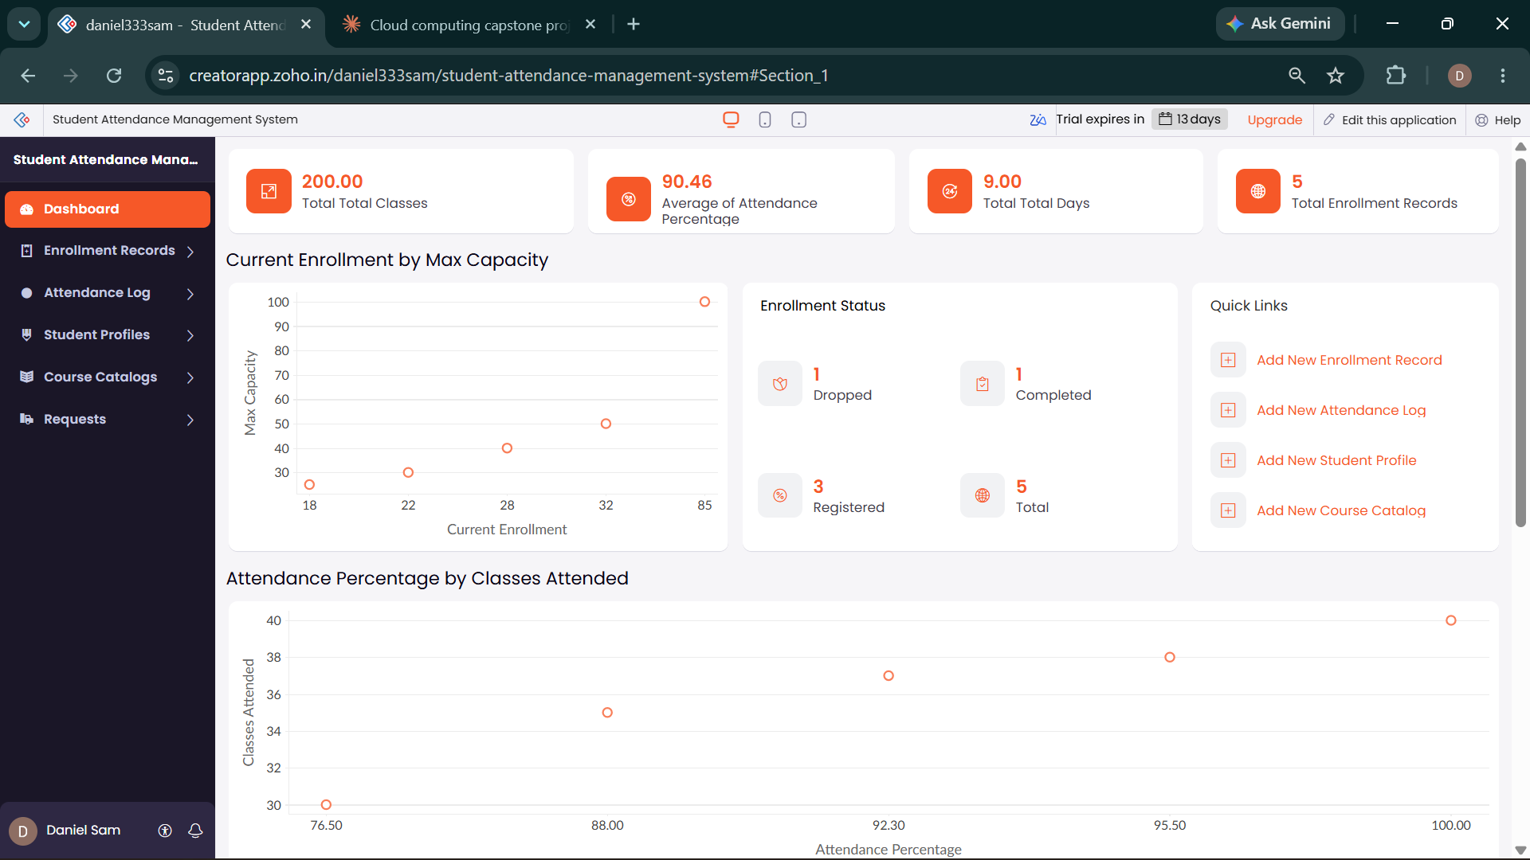

QUESTION 8
Create a simple cloud web application for student counselling system using any Cloud Service Provider to demonstrate SaaS with the fields of student name, age, address, phone, subjects studied, Year of passing, percentage of marks, domain interest, etc.
Aim: To develop a simple cloud-based student counselling application demonstrating SaaS for maintaining student academic and career-interest details.
Output
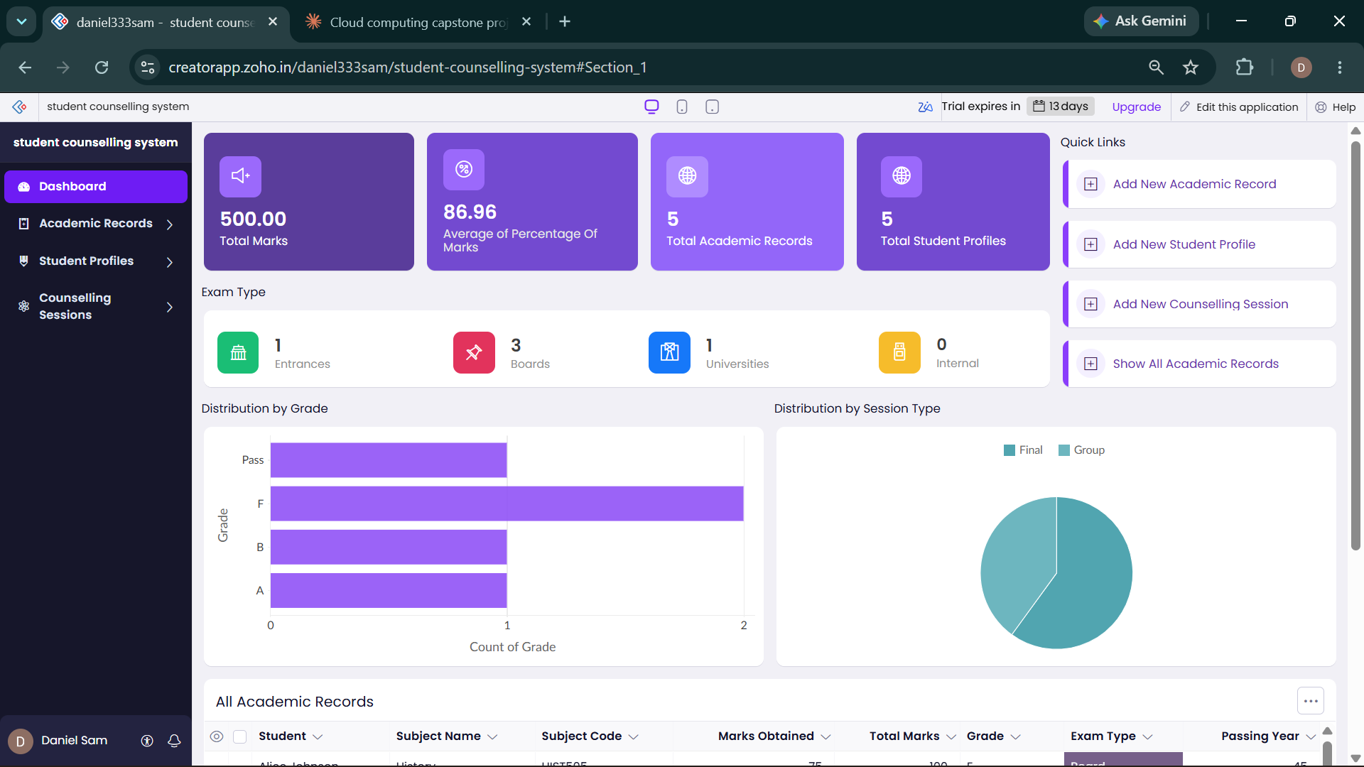

QUESTION 9
Create a simple cloud software application for Hospital information system for SIMATS Hospital using any Cloud Service Provider to demonstrate SaaS with fields of patient name, age, address, phone, email, Attender name, attender phone, doctor name, diseases, etc.
Aim: To develop a simple cloud-based hospital information application demonstrating SaaS for managing patient, attendant, doctor and disease details.
Output
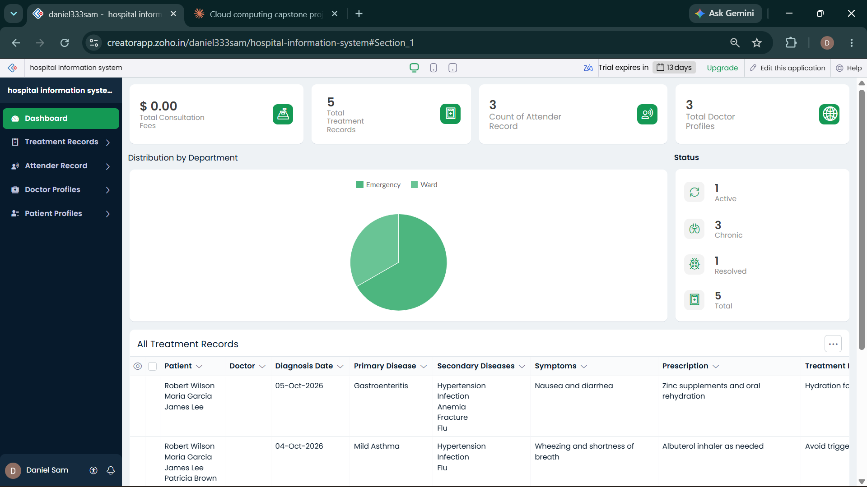

QUESTION 10
Create a simple cloud software application to run a c program to display the student information using any Cloud Service Provider to demonstrate SaaS with the template of student name, reg no, address, phone, age, courses, grades and attendance report, progress report, Semester mark sheet forms.
Aim: To develop a simple cloud-based C-program application demonstrating SaaS for displaying and managing student information and academic reports.
Output
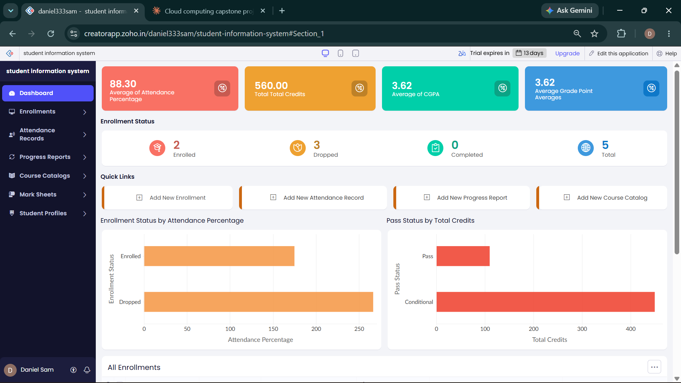

QUESTION 11
Create a simple cloud software application for online super market using any Cloud Service Provider to demonstrate SaaS with the template of customer name, address, phone, email, items, quantity etc. with the item classification form.
Aim: To develop a simple cloud-based online supermarket application demonstrating SaaS for customer, item, quantity and item-classification details.
Output
